Queen`s Airway Management Course
Saturday-7Th Septeber`24
Department of anaesthesia & critical care announces free airway management course for senior trainees above ST5 grades and CESR candidates who has submitted papers to the college. Free lunch and gala dinner after the course. Candidates will be required to deposit £100 (refunded on the day of the course)

The course includes hands on training on crucial airway techniques including
Guest Lectures by renowned faculties, Simulation, Airway emergencies- Blocked airway/ Tracheostomy, Training for bleeding and soiled airway “SALAD”, Bridging the gap between human and simulation with ORSIM & Oxford box, Airway & gastric ultrasound , If all fails!- FONA (Front of neck access) , Conduit intubation, Awake Tracheal Intubation, tips by experts , Obstetric airway, Jet Ventilation & Many more. Number of delegates limited, renowned workshop faculties.

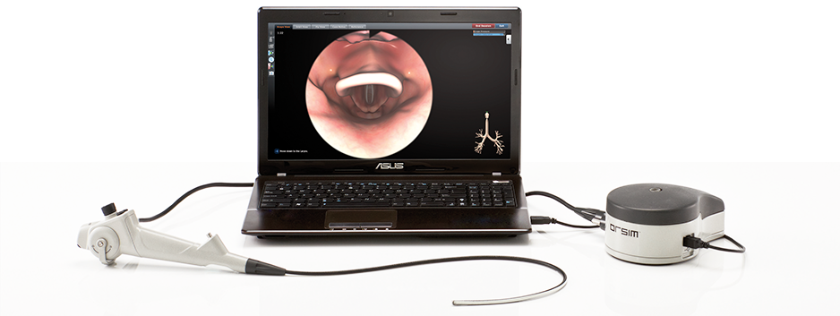
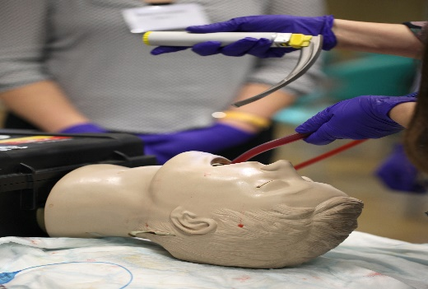

To book a place please contact:
gyanendra.upmanyu3@nhs.net
Venue: Education Centre , Queens Hospital Romford, RM7 0AG.
Fees: £100 (Refunded on the day of the course)

