DIFFICULT AIRWAY SOCIETY
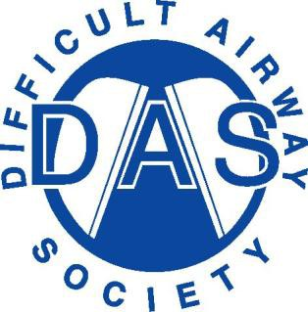

21 Portland Place London W1B 1PY
Tel: 0207 631 8899
Email: das@anaesthetists.org

Difficult Airway Society
DAS Trainee Representative

Dear DAS member,

We are delighted to announce that applications for the role of Trainee Representative are now welcome from Full (UK & Irish) members of DAS in good standing.

The role of Trainee Representative is multi-faceted and is influenced by the skills and preferences of the individual. This will include leading on the DAS Trainee Social Media platforms, editing the DAS eZine as well as contributions to other facets of the Society’s output (such as webinars and guidelines). The emphasis is on education as well as providing a trainee perspective on matters arising within the committee.

Demonstrable evidence of a prior interest in airway management is advantageous, but not a prerequisite.

Application process:
- The trainee representative must be post-FRCA / FFARCSI and have a minimum of 18 months from their CCT (and hence can continue 6 months post-CCT).
- Applications are open from 1st September to 23:59 (BST) on 30th September 2023.
- A cover letter and CV are then reviewed by DAS Executive and the top 3 candidates invited to interview.
- Interviews will be conducted from the 16th October
- Results will be announced to members on 1st December at the DAS Annual Members Meeting.
- The tenure of DAS Trainee Representative will be for a fixed 2-year term from announcement of results.

If you are interested in applying, please submit a cover letter and CV to the DAS Secretariat at DAS@anaesthetists.org.

Closing date: 23:59 (BST) 30th September 2023

Kind Regards,

Dr Ravi Bhagrath
DAS Honorary Secretary

