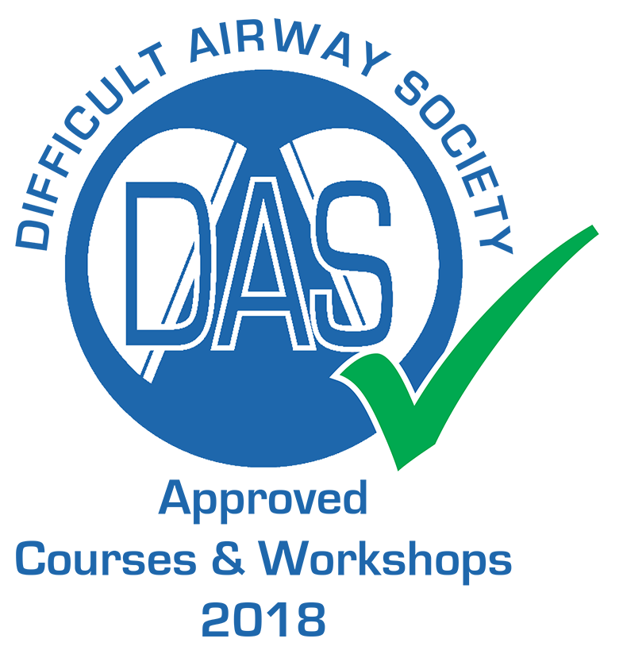

10th St George’s Airway Refresher Day 2020
for Anaesthetic Consultants and non-trainee grades of Anaesthetists St George's Advanced Patient Simulator Centre (GAPS)
4th Floor, Hunter Wing, St George’s Hospital, London

Thursday 16th January 2020
A hands-on day to refresh your airway skills and decision-making
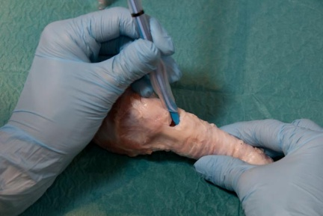
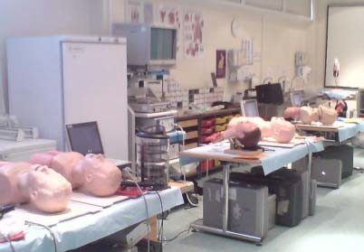

09:00 Registration and coffee
09:30 Welcome and overview of the day
09:40 DAS guidelines, what's new? Dr Sombith Maitra
10:10 DAS 2018 update. Dr Sabeen Khan
10:45 Awake FOI techniques (sedation techniques, topicalisation techniques) Dr Anna Walton.
12:00 Lunch
12:45 Group A - max 12 Surgical cricothyroidotomy
14:15 Coffee
14:30 Group B - max 12 Workshops
Airtraq, Glidescope, C-MAC
Bonfils
Low skill FOI
Exchange Catheters
THRIVE
Ultrasound neck
16:00 Closure

CPD matrix: 1C02, 2A01, 1B02, 1I02, 3A01

Course Fee: £165

CPD
Approved by the Royal College of Anaesthetists as external CPD (5 CPD points) and by DAS.

Contact details
Registration queries: Robert Colson at the Simulation Centre: 020 8725 3574, Robert.Colson@stgeorges.nhs.uk

Course Organisers
Dr Kanika Dua, Consultant H&N Anaesthetist
Dr Jelena Devic, Consultant H&N Anaesthetist
Dr Elena Kourteli, Consultant H&N Anaesthetist, Elena.Kourteli@nhs.net

Faculty

Kanika Dua. Consultant Anaesthetist, St George’s University Hospitals, London
Jelena Devic. Consultant Anaesthetist, St George’s University Hospitals, London
Adam Shonfeld. Consultant H&N Anaesthetist, St George’s Hospital, London
Rehana Iqbal Consultant H&N Anaesthetist, St George’s Hospital, London
Elena Kourteli, Consultant Anaesthetist, St George’s University Hospitals, London
Karen Light, Consultant Anaesthetist, St George’s University Hospitals, London
Aasifa Tredray Consultant Anaesthetist, St George’s University Hospitals, London
Anna Walton, Consultant Anaesthetist, St George’s University Hospitals, London
Fauzia Mir, Consultant Anaesthetist, St George’s University Hospitals, London
Sombith Maitra, Consultant Anaesthetist, Kingston Hospital
Sabeen Khan. Airway Fellow 2017. St George’s Hospital
Clare Ivermee. Airway Fellow, St George’s University Hospitals, London
Zara Edwards, Airway Fellow, St George’s University Hospitals, London

GAPS Simulation Staff

Robert Colson, Clinical Skills & Simulation Co-ordinator
Nicholas Gosling, Head of Simulation & Skills, Advanced Patient Simulation
Andrew Sykes, Simulation Engineer
Philippa Newman, Simulation Administrator
Ivy Hagan

Sponsors

