Queen`s Airway Management Course
Wednesday 29/01/2020
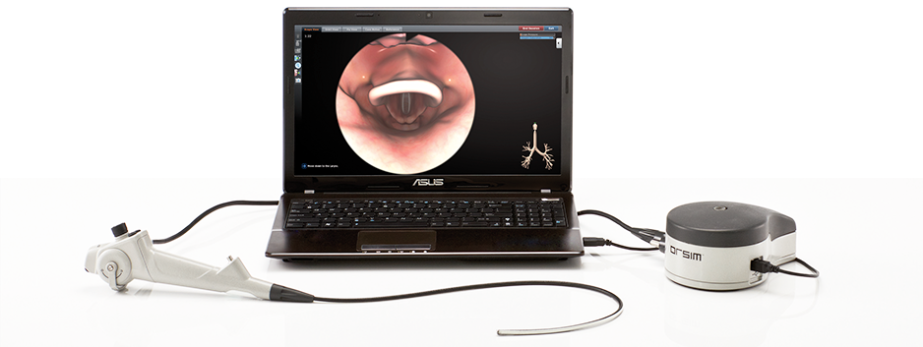
After the grand success of QAMC- 2019, you are invited to apply for QAMC-2020
Guest lecture & debate followed by:

Hands on training in crucial airway techniques
Simulation, Airway emergencies- Blocked airway/ Tracheostomy, Novel Training for bleeding and soiled airway “SALAD”, Bridging the gap between human and simulation with ORSIM & Oxford box, Airway ultrasound , If all fails!- FONA (Front of neck access) , Conduit intubation, Awake Tracheal Intubation, Paediatric video laryngoscopy & fibre-optic intubation tips and management by experts, Adult video laryngoscopy, Percutaneous tracheostomy, Surgical tracheostomy , Double lumen insertion, Optiflow & thrive, New innovations of 2019!, Obstetric airway, Jet Ventilation & Many more. Number of delegates limited, Renowned Faculties, faculty to delegate’s ratio 1:2.

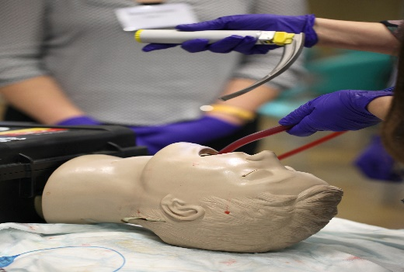
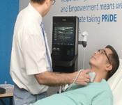
To book a place please contact: Dr G. Upmanyu
On gyanendra.upmanyu3@nhs.net
Discounted rates till 31-12-2019: Doctors-£100 after that £200.

