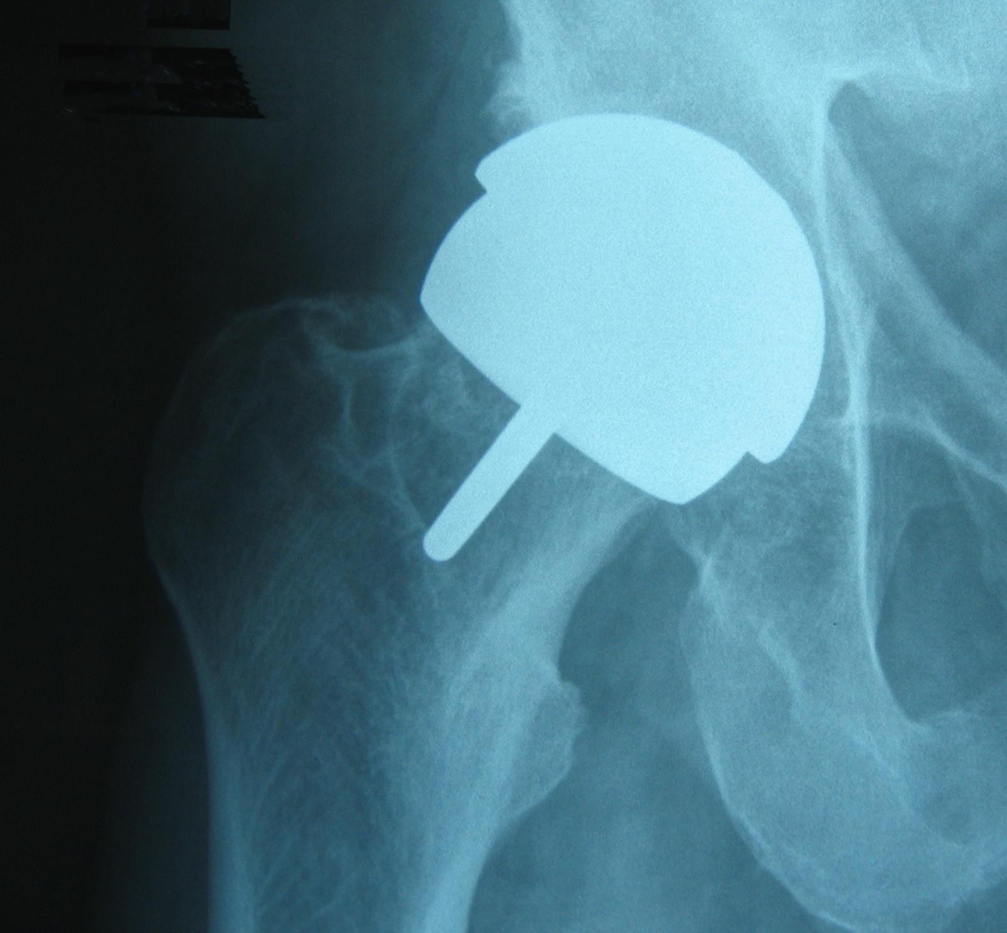
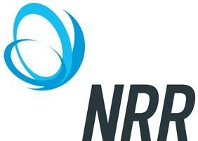
NEWCASTLE PERCUTANEOUS

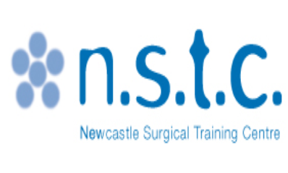TRACHEOSTOMY COURSE

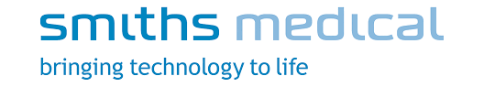
Date: 9th September 2019

NEWCASTLE SURGICAL TRAINING CENTRE,
FREEMAN HOSPITAL

The Newcastle Percutaneous Tracheostomy Course is designed to provide trainees with a basic skills set required to facilitate their entry into higher surgical training. The course will employ a series of technical and non-technical human factors simulation to guide trainees through different aspects and expectations of their training.
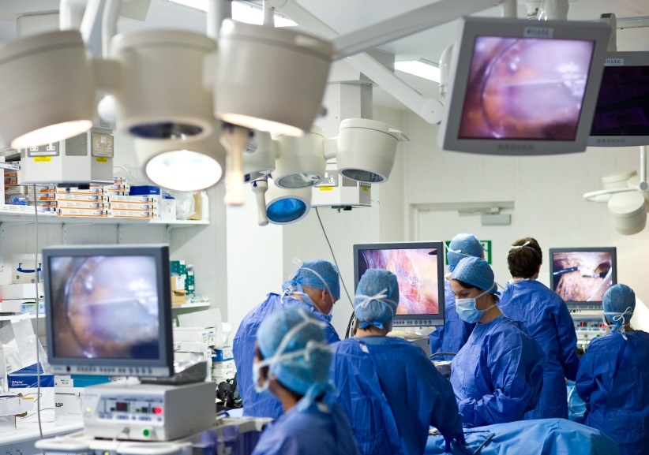
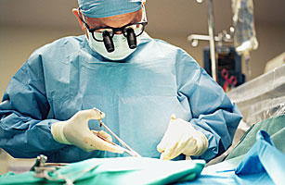
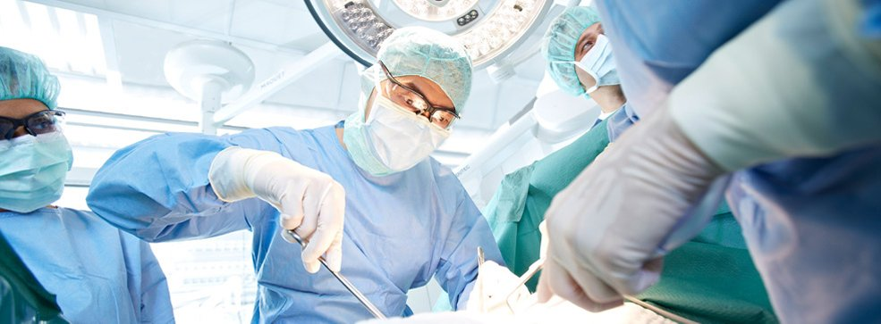

REGISTRATION FEE

Consultants & Training Grades: £150

Nurses/Allied Professionals: £125

Includes refreshments, morning break and lunch

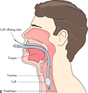

For registration and further information:

Louise.sore@nuth.nhs.uk
Tel: 0191 2138589

Methods of payment: We require full payment prior to the start of the activity. Payments by credit card or BACS only. The registration fee includes instructional materials continental breakfast, refreshment breaks and lunch.

Accreditation Statement
The NSTC is accredited by the Royal College of Surgeons of England

OBJECTIVES

After attending this activity, the participants will demonstrate the ability to:
- Implement proper patient selection for tracheostomy.

- Recognize a potential complex airway and list various techniques for advance airway management.

- Perform percutaneous tracheostomy and other airway techniques on a cadaver model.

COURSE DIRECTORS
Dr Shaun McMahon –
Consultant Anesthetist, Newcastle upon Tyne Hospitals
Dr Suzanne O`Neill,
Consultant Anaethetist , Newcastle upon Tyne Hospitals

Faculty include:
Dr Hugo Velasquez, Dr Andrew McQueen,
Dr Linda Waddilove t/c, Ms Laura Warner,
Dr James Lennard

CONTENT AND DELIVERY

The programme is based on trainees rotating through specifically designed skill stations over 1 day. These will be interspersed by a few short didactic lectures and hands on procedures on porcine tissue

Description

This full day course will begin with mini-didactic lectures of fundamental knowledge and panel case based discussions. The course will be focused on hands-on training with our faculty in small groups. This course is designed to provide participants with an interactive hands-on experience in percutaneous tracheostomy and advanced airway devices using simulation models and cadavers.

Who should attend:

This activity is intended for the following specialites: ENT, Critical Care, Anesthetists, Emergency Medicine, Respiratory Physicians and Nurse Practitioners.
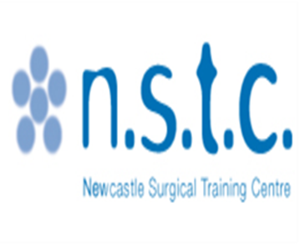

Percutaneous Tracheostomy Course
9th September 2019

8:00 – 8:30 | Welcome and Introduction | Smiths Medical | Lecture Theatre
8:30 – 9:30 | Percutaneous Tracheostomy technique  Open vs Percutaneous | Dr Shaun McMahon  Ms Laura Warner | Lecture Theatre
9:30 – 10:30 | Smith Medical Uniperc for challenging anatomy (pig model) | All Faculty | Theatre 1 & 2
10:30 – 10:50 | Refreshments |  | NSTC Coffee area
10:50 – 11:50 | Dilatational forceps (Griggs) technique  Standard percutaneous technique | Dr S O`Neill, Smiths Medical and faculty | Theatre 1 & 2
11:50 – 12:40 | Ultrasonography of the neck and cricothyroid membrane – techniques to identify the cricothyroid membrane and trachea | Andrew McQueen | Lecture Theatre
12:40 – 13:10 | Lunch |  | NSCT Coffee area
13:10 – 14:00 | Emergency Front of neck  Access technique – how to perform FONA with scalpel bougie technique | Hugo Velasquez  Linda Waddilove t/c | Theatre 1 & 2
14.00-14.20 | Refreshments |  | NSTC Coffee area
14:20 – 15:50 | Management of tracheostomy emergencies  And case discussion – National patient safety work algorithms at the bedside | Dr Shaun MaMahon  Linda Waddilove t/c  J Lennard | Theatre 1 & 2
15:50 | Closing remarks & evaluation |  | Lecture Theatre

